Property Price Prediction Project – Summary Report
By Ajay Kumar Sahu (Post-Graduate Program in Data Science & Artificial Intelligence)
A Project by Digicrome Academy, Noida

1. Introduction to the Project
This project focuses on building a machine learning model to predict property prices based on various features such as area, quality, location, and amenities. The aim is to assist buyers, sellers, and real estate professionals in making data-driven decisions.

2. Objectives of the Project
• To collect and clean real estate data.
• To handle ordinal and nominal variables separately.
• To apply scaling, PCA, and missing value treatment.
• To perform EDA.
• To build and evaluate ML models.
• To deploy a predictive model.

3. Flow Chart of Operations
Data Collection → Data Cleaning → EDA → Feature Engineering → Encoding → Scaling & PCA → Model Training → Model Evaluation → Deployment

4. Python Codes
The project uses Python libraries such as pandas, numpy, matplotlib, seaborn, and scikit-learn. The code includes data preprocessing, visualization, model training, evaluation, and saving the trained model.

5. Screenshot of the Outputs
Screenshots include:
• Distribution of Property Prices
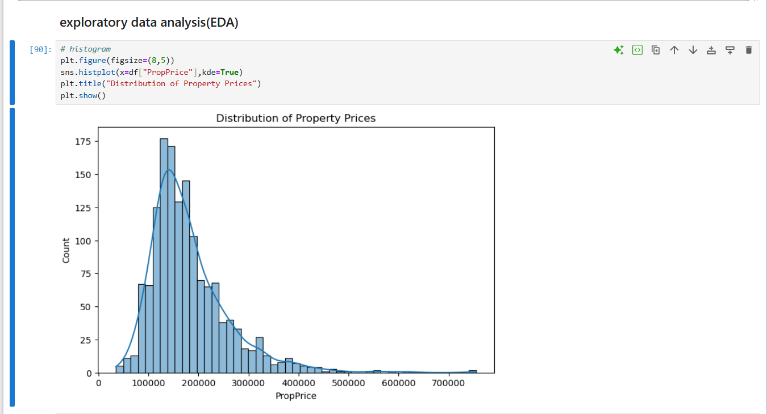
• Living Area vs Price Scatter Plot
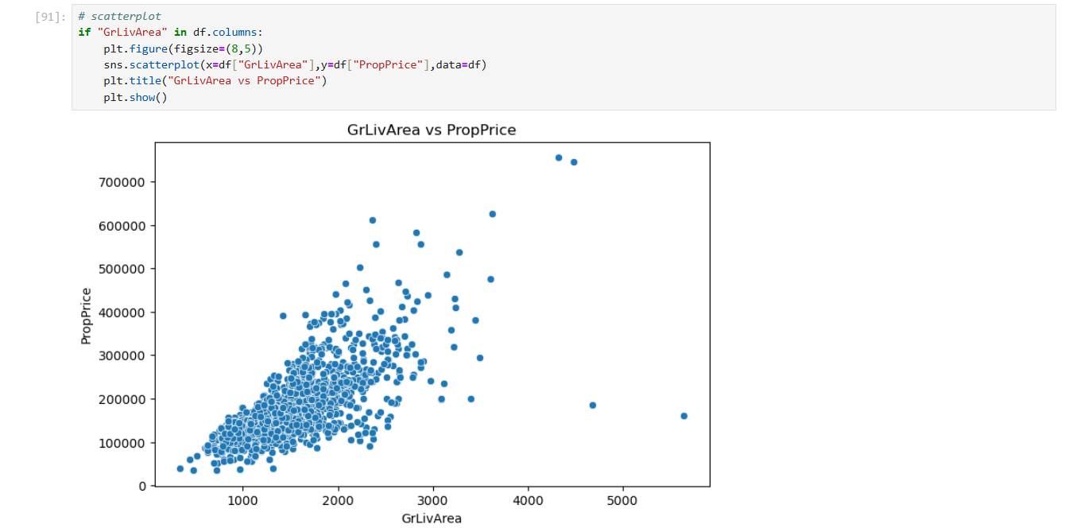
• Model Evaluation Metrics (R2, MAE, RMSE)
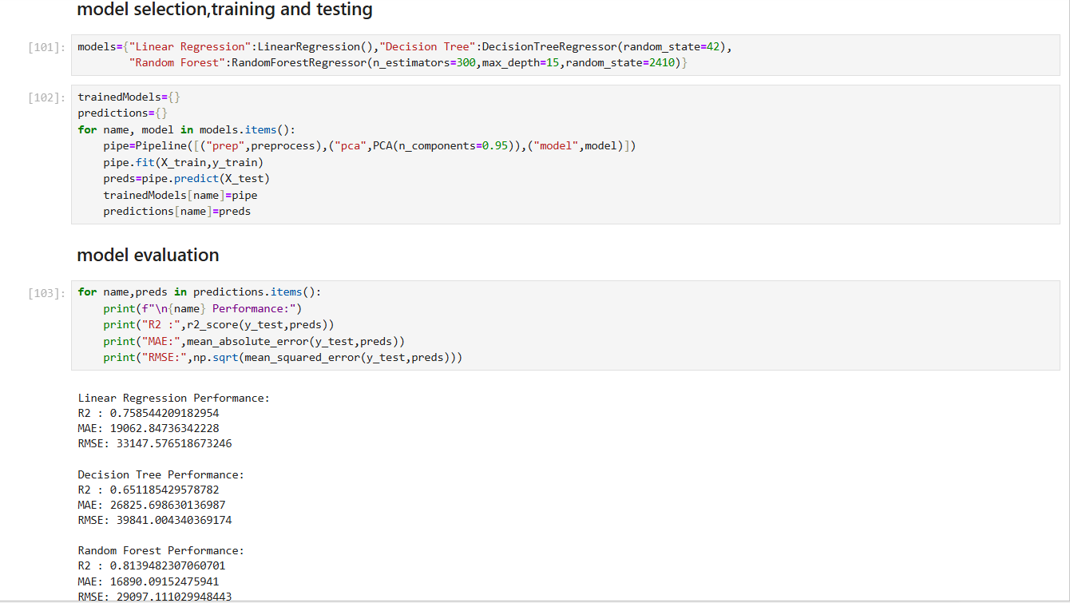

6. Report on EDA
EDA revealed that variables like Overall Quality, Living Area, and Total Bathrooms strongly influence property prices. Visualizations such as histograms, scatter plots, and boxplots were used.

7. Learning Outcomes
• Learned real-world data cleaning
• Understood feature engineering
• Gained experience with ML models
• Learned evaluation techniques
• Understood model deployment using .pkl

8. Conclusion
The project successfully demonstrates an end-to-end ML workflow. Random Forest performed best with high R² score, making it suitable for price prediction.
--Thank You--

